UPPWISE INDIA

www.uppwise.com



**Quaterly Development Planning**

**Q1-2024**

**Feature: Add Column to Document Register and Workspace Document Widget – Phase 2**

**Feature Title:**

Add Column to Document Register and Workspace Document Widget – Phase 2

**Priority:**

Medium

**Submitted By:**

SPM

**Target Users:**

Standard – Customer: AXA

**Feature Description:**

This feature aims to enhance the document management capabilities within the teamspace environment by introducing a new column titled "Available Files." This column will display the files that are attached to each document listed in the document register and within the document widget in the workspace. – Basically this feature is similar to the earlier one, here only mentioned the enhanced approach in terms of UX perspective and try to sync with the standard approach.

**Acceptance Criteria:**

**Attachment Handling:**

* We can show a standard attachment icon along with the count over it so that user can get understanding like how many files are there.
* If a document has multiple files attached, the "Available Files" column should provide a clear indication of each file's name through the tooltip or via opening a standard attachmnet popup (via attachmnet icon in the column).

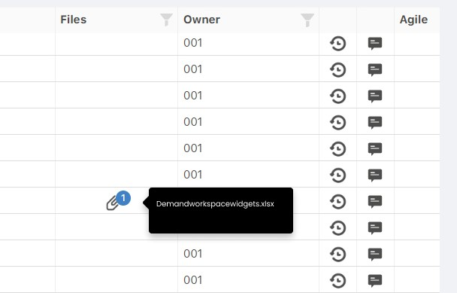

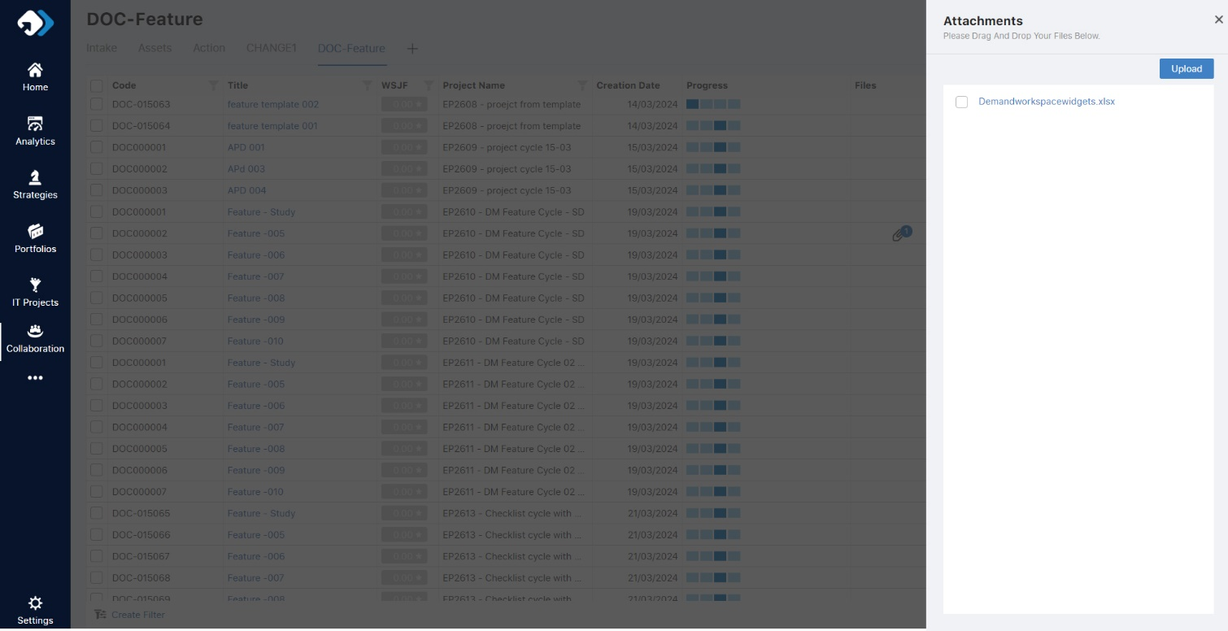

**Note**: Same kind of implementation can go over the Document widget under the workspace